SCIENTIFIC SUPPORT DOCUMENT FOR WORKFLOWS’ DEVELOPMENT BY ICT EXPERTS
Guidelines to help translating research questions into ICT requirements

- WORKFLOW TITLE – ICP Programs Workflow: Automated Data Validation Workflow for Environmental Forest Samples in European ICP Monitoring Programs (ICP Forests & ICP IM)

- COLLABORATORS –
Collaborator | Affiliation | Role in the Workflow | Contact
David Elustondo | BIOMA Institute – UNAV | Coordinator | delusto@unav.es
Esther Laseras | BIOMA Institute – UNAV | Scientific leader | elasheras@unav.es
Sheila Izquieta | BIOMA Institute – UNAV | Development Inovation director | sizquieta@unav.es
Julen Torrens | BIOMA Institute – UNAV | Data Scientist | jtorrens@unav.es
Nicolas Goyena | BIOMA Institute – UNAV | Data Scientist | ngoyenaserv@unav.es

- CONTEXT & SCIENTIFIC QUESTIONS TO BE ANSWERED
Background of VRE- Since the 1980s, European forests have been continuously monitored due to growing concerns about the impacts of atmospheric pollution and, more recently, climate change. In response to these environmental challenges, international programmes such as the International Co-operative Programme on Assessment and Monitoring of Air Pollution Effects on Forests (ICP Forests) and the International Co-operative Programme on Integrated Monitoring of Air Pollution Effects on Ecosystems (ICP IM) were established under the Convention on Long-range Transboundary Air Pollution (CLRTAP), coordinated by the United Nations Economic Commission for Europe (UNECE):
- The ICP Forests programme, launched in 1985, monitors forest condition across Europe using two levels of intensity. The Level I monitoring network is based on a systematic 16 × 16 km grid and currently includes 5,706 plots (as of 2023), providing large-scale spatial data to evaluate geographic and temporal variations in forest health. In contrast, Level II monitoring focuses on a smaller number of intensively studied plots (640 as of 2022), where more detailed and frequent measurements are conducted to better understand cause–effect relationships between atmospheric pollution and ecosystem responses. In Spain, the national ICP Forests network contributes 14 Level II plots to this European effort.
- The ICP Integrated Monitoring (ICP IM) programme aims to assess the ecological effects of air pollutants through long-term, integrated observations of ecosystems. This monitoring involves simultaneous measurements of physical, chemical, and biological parameters across multiple environmental compartments—such as soil, water, and vegetation—over extended periods at the same locations. Currently, 48 active stations are part of the IM Level 3 monitoring programme, with participation from 15 European countries, including one site in Spain (ES02, monitored by BIOMA – University of Navarra).
These programmes have provided long-term datasets essential for assessing forest and ecosystem health, identifying environmental trends, and informing environmental policy across Europe. Together, they offer a comprehensive view of how ecosystems respond to multiple stressors, including acid deposition, nitrogen and sulphur inputs, tropospheric ozone, heavy metals, and the increasing influence of climate change.
Introduction of the first Workflow (Chemical Validation of lab raw results) - Despite the large volume of data collected by ICP networks, significant challenges remain in terms of accessibility, integration, and long-term digitalisation. At each sampling site, multiple types of samples are collected (each sample type corresponds to a specific subprogram)—water, soil, organic matter, air, and biodiversity—each requiring specific laboratory analyses. This results in highly heterogeneous datasets across numerous parameters, making robust validation essential to ensure data quality and reliability.
Many validation and processing steps are still performed manually, leading to workflows that are slow, error-prone, and difficult to reproduce. In this context, this project aims to develop an automated workflow to standardise validation procedures before reporting data, improving consistency, efficiency, and transparency.
So, within the ICP programmes, results are reported according to specific subprogrammes, each corresponding to different sampling strategies and environmental compartments. This project initially focuses on water-related subprogrammes, as they involve more complex validation procedures.
Although water samples are collected using different methodologies depending on the subprogramme, the laboratory analysis performed is the same across all of , and the parameters measured are identical. Consequently, data validation procedures are also identical for all water samples.
For this reason, standardised templates are shared across all water subprogrammes. These templates are organised by parameter groups (AMMONIUM, CATIONS, ANIONS, DOC_TN, WEIGHTED pH, WEIGHTED CONDUCTIVITY), and each row represents an individual sample. Importantly, samples from different subprogrammes can be included within the same template, as they are analytically equivalent.
The distinction between subprogrammes therefore lies not in the analysis, but in the sampling methodology used to collect the water. To preserve this information, templates must be accompanied by a sampling typology file, which links each sample (via a unique identifier) to its corresponding subprogramme, sampling type, location, and other relevant metadata.
Water Subprogrammes:
The project covers several ICP-Forests and ICP Integrated Monitoring (ICP-IM) subprogrammes (which are equivalent across both programmes), including:
- Precipitation Chemistry (PC): Measures bulk deposition in open areas to quantify wet deposition inputs.
- Throughfall (TF): Measures water passing through the forest canopy, reflecting canopy interactions.
- Stemflow (SF): Captures water flowing down tree stems, providing insights into localized fluxes.
- Soil Water (SW): Monitors soil solution chemistry to assess processes such as acidification and nitrogen dynamics.
- Runoff Water (RW): Analyses catchment outflows to estimate element export via hydrological pathways.
Although these subprogrammes differ in how water samples are collected, all resulting samples undergo the same laboratory analyses and validation procedures.
Input Data Structure and Workflow:
Data flows through four well-defined quality levels (4 processing levels):
Level | Name | Description
Level 0 | Raw data | Laboratory results recorded directly into standardized templates. No processing applied.
Level 1 | Pre-processed | Data that have passed initial format validation and undergone basic transformations: unit conversions, detection limit checks, alkalinity transformation, weighted means.
Level 2 | Chemically validated | Advanced physicochemical checks for each sample: ion balance, conductivity consistency, Na/Cl ratio, organic nitrogen estimation, and more.
Level 3 | Reporting-ready | Fully validated data, selected per sample priority rules (NOREP/REP logic), ready for database ingestion and reporting.

For all samples measured, researchers must complete standardised templates provided by us with laboratory results. These templates represent Level 0 data, serving as the entry point for automated processing. Each template covers one parameter group, and each row represents a single analytical sample — regardless of its subprogramme. Templates are named following this convention:
YYYY – Year, MM – Month, SITECODE – Site identifier, PARAMETER GROUP (Examples: 2025_02_ANIONS.xlsx;2025_02_FOREST_ALKALINITY_REP.xlsx).
Where REP is appended when the template contains repeated laboratory analyses (when the first validation check does not pass, see next Section). So, each file contains multiple rows, where each row corresponds to a single sample, regardless of its subprogramme.
Additionally, a sampling typology file is required for the workflow. This file:
- Identifies each sample using a unique identifier (col: SampleID)
- Specifies the associated subprogramme (col: ICP_Program)
- Includes sampling type depending on the forest type, location, and optional metadata (cols: SamplingTypology, SiteCode, SiteName), since this information is important for the chemical validation too.
This file is essential to correctly interpret and group samples during processing. The different sampling typologies are as follows (See the example of the samplesInfo.xlsx file in GitLab under Component 5, where this file is required for the first time.):
Acronyms for sampling typology | Mean
BOF | Bulk open fields
WET | Wet only open fields
THR | Throughfall
STF | Steamflow
SW | Soil water
BL | Broad leaves

Validation and Repeated Samples:
Water samples must meet strict validation criteria. When samples fail initial validation, ICP guidelines recommend repeating the laboratory analysis.
As a result, the workflow may include:
- NOREP: Original samples (original naming, explained below)
- REP: Repeated samples (The same naming convention is used, with _REP added at the end of the filename).
These are initially treated independently as different samples (different rows). If only certain parameters are reanalysed, missing values are completed using the original data (from NOREP file). Therefore, when processing repeated samples, the original dataset must also be reintroduced into the workflow (NOREP + REP files)
Final reporting follows these rules:
- If the original (NOREP) sample passes validation → use NOREP data
- If the repeated sample passes validation → use REP data
- If repeated sample fails → retain original (NOREP) data
Sampling Strategy and Its Implications for Data Templates
During field campaigns, multiple water samples are collected depending on the subprogramme and sampling design. Importantly, a single subprogramme or sampling procedure may have more than one sample (i.e., more than one row in the template), as it may involve multiple collectors or subsamples.
For example:
- In precipitation-related subprogrammes (e.g., PC or TF), water is often collected using multiple collectors (e.g., several bottles distributed in the field).
- These individual collectors may later be:
  - Analysed separately, or
  - Combined into composite samples (e.g., grouped mixtures), depending on laboratory protocols.
- In contrast, for soil water (SW), typically only one sample per sampling method is collected.
As a result, the number of samples reported in the templates depends on how the samples are processed in the laboratory, not strictly on the subprogramme itself (there may be more than one subsample within each subprogramme or sampling procedure). Each row in the templates always represents to one unique analytical sample, regardless of its origin or how many collectors contributed to it. Each sample or subsample is identified by the values in the SampleID column.
Example: If 10 collectors are used for precipitation, these may be combined into 2 composite samples (e.g., 5 + 5 collectors) and the lab analysis is made from these 2 mixes. Therefore, the templates will contain 2 rows, not 10. Both rows correspond to the same subprogramme (e.g., TF), but represent different composite samples. At later stages (reporting), samples belonging to the same subprogramme and collected during the same sampling campaign may be aggregated using volume-weighted averages, but this aggregation is not performed in the initial stages of the workflow.
Template Structure and Sample Representation (See template examples in GitLab)
All templates follow a consistent structure where each row corresponds to a single analytical sample.
- AMMONIUM:
SampleID | ScodeICPIM | SiteCode | SiteName | EndDate | NH4N | Comments
- CATIONS:
SampleID | ScodeICPIM | SiteCode | SiteName | EndDate | Ca | Mg | Na | K | Al | Fe | Mn | As | Cd | Co | Cr | Cu | Ni | Pb | Zn | P | S | Comments
- ANIONS:
SampleID | ScodeICPIM | SiteCode | SiteName | EndDate | Cl | NO₃ | SO₄ | PO₄ | Comments
- DOC/TN:
SampleID | ScodeICPIM | SiteCode | SiteName | EndDate | DOC | TN | Comments

Special Case 1: pH and Conductivity Template
The pH and conductivity template differs from the others in a fundamental way.
Unlike the rest of the parameters, pH and conductivity measurements are performed on each individual collector (e.g., all 10 bottles), not on the composite samples. This results in multiple rows per final sample group.
Structure:
StartDate | EndDate | SiteCode | SiteName | SampleID | Collector | Tare | Tare+Sample | Volume | Saturated | Precipitation | Conductivity | Temperature | pH | DO (%) | DO (ppm) | Comments
To make these data consistent with the rest of the templates, individual collector measurements are grouped (e.g., 5 + 5 collectors), and a volume-weighted average is calculated for each group of the parameters measured here. This produces the same number of final samples as in the other templates (e.g., 2 rows). Thus, for pH and electrical conductivity, a volume-weighted calculation must be performed beforehand (to identify which samples belong to the same mix, we include a ‘group’ column in the template.). Later, during reporting, these grouped samples may again be aggregated into a single value per subprogramme using weighted averaging for the final report.
Special Case 2: Alkalinity
Alkalinity is treated as a special case because, although it is measured on already composited samples (two mixes) as well as the rest of parameters, each sample is analysed through multiple titration steps rather than a single measurement (Gran Method). During the analysis, successive small volumes of acid are added to the sample while recording pH, generating a series of data points instead of a single value. These measurements are stored in the template and later used to calculate total alkalinity using the Gran method, producing a single final alkalinity value for each sample.
Template Structure:
SampleID | SiteCode | SiteName | Year | Month | HCl Volume | pH | HCl (mol/L) | Sampling Volume | Comments
So, the calculation of alkalinity follows the Gran method, which is widely recommended for low alkalinity values (Gran, 1952). This method relies on a linear relationship to determine the equivalence point of the titration. This approach is considered highly precise, particularly for low-alkalinity waters, and allows a more robust estimation compared to single-point methods. In the template, different rows may share the same ID because multiple sampling points belong to the same sample. After Step 2, these multiple points are aggregated into a single point representing each sample.
Key Takeaways
- A sample ≠ subprogramme → multiple samples per subprogramme are possible
- Templates always store individual analytical samples (rows)
- Differences in sampling only affect:
  - Number of rows
  - Grouping logic
- Validation is identical across all water samples
- Aggregation (weighted averages) occurs after validation, not before
- pH/conductivity and alkalinity require specific preprocessing steps


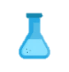








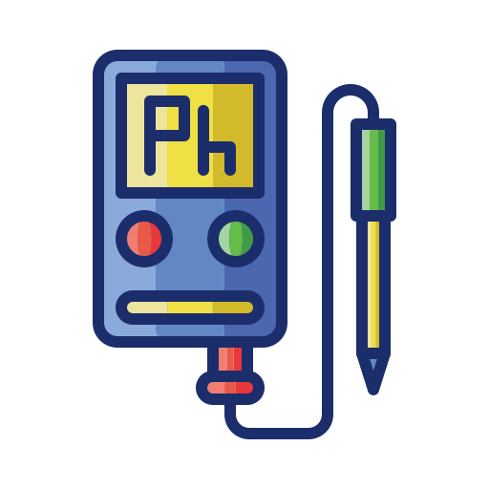
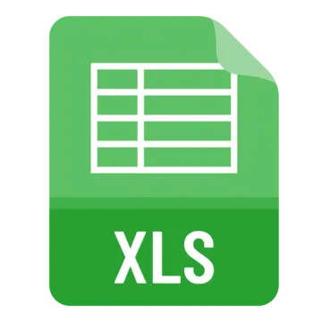
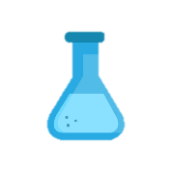









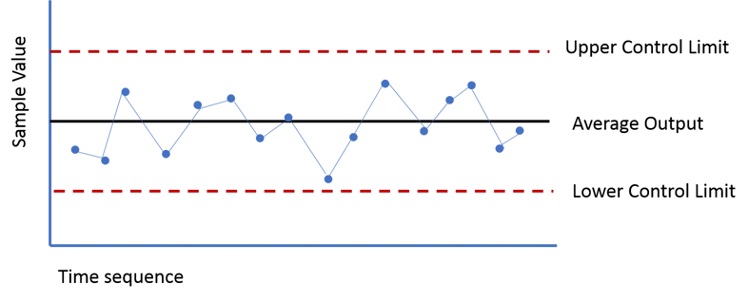













Data collection: BIOMA researchers in this step, measure and record the weight, pH, and electrical conductivity of each collector at every site, and enter the data into the prepared templates.
Collection of samples in ES02 and sending them to laboratory.
In the lab samplers are divided and mixed into two samples.
Collection of samples are sending them to laboratory.
In the lab samplers are mixed in only one mix. We finally get unique samples, one per site.
ICP FOREST
ICP IM
Weighted pH and E.C estimation for different subprograms (TF, PC, RW, SF, SW) mixes
Cation’s analysis
Anion’s analysis
Ammonium analysis
Doc Tn analysis
Alkalinity analysis
Controls Chart: After lab controls are passed, the templates for each group of parameters are filled out.
Data collection: After lab controls are passed, BIOMA researchers record the data using the prepared templates for each group of parameters (ANIONS, CATIONS, DOC/TN, AMMONIUM and ALKALINITY) and WEIGHTED pH and EC.
Data transformation and validation: The transformation and validation scripts are executed for each template type, and a report is generated indicating which samples need to be repeated.
Weighted mean if necessary: In the case of ICP-IM, we have two composite samples for each subprogram. Therefore, to report a single value, we need to calculate an additional weighted mean.
Data storage: At BIOMA, the processed data are stored in our internal database, including the latest validated and quality-checked version.
If a sample does not pass validation, the laboratory analysis of that sample is repeated and then the validation process is performed again. This step is carried out only once. If the sample fails validation on two occasions, the result from the first analysis is retained
ICP IM
ICP Forest
All computational analyses have been carried out and automatized using workflows within the LifeWatch platform

Workflow Resume (Based on the diagram below)
The workflow begins with field sampling, where multiple water collectors are deployed at each monitoring site depending on the subprogramme. For example, in precipitation-related subprogrammes (e.g., TF or PC), several collectors are used simultaneously to capture spatial variability.
After collection, all samples are transported to the laboratory. At this stage, different situations may occur depending on the sampling design:
- In some cases, all collectors are combined into a single composite sample per site
- In other cases, collectors are grouped into multiple composite samples (e.g., two mixtures per site), depending on laboratory protocols
- In the case where there is only one subsample, there is no need to mix it, since there are no others. If there are two samples and it is decided not to mix them, then they are kept separate.
- Each laboratory decides how many samples to keep or whether to pool them.
As illustrated in the diagram, this process determines the number of analytical samples, not the subprogramme itself. For instance, if collectors are grouped into two mixtures, the resulting dataset will contain two samples (i.e., two rows in the templates) for that subprogramme and site.
A key distinction in the workflow is the treatment of pH and electrical conductivity:
- These parameters are measured directly on each individual collector before mixing
- This results in multiple measurements per site (e.g., one per bottle)
- Afterward, values are aggregated into the same composite structure used for the rest of the parameters (e.g., two groups or one) using volume-weighted averages if necessary
This ensures consistency between the pH/conductivity dataset and the rest of the chemical analyses.
Once composite samples are defined, laboratory analyses are performed for all chemical parameters (e.g., ammonium, cations, anions, DOC/TN, alkalinity). Results are recorded in standardized templates (Level 0 data), where:
- Each row represents a single analytical sample
- Samples from different subprogrammes may coexist within the same template
- The number of rows reflects the number of composite samples generated in the laboratory
- In the case of alkalinity, there may be more than one row per sample (Gran method – see below special case 2), but this can be easily identified using the unique identifier for each one, i.e., a unique identifier per sample.
The completed templates enter the automated workflow, where:
- Data undergo initial format validation and preprocessing (Level 1)
- Advanced chemical validation is applied (Level 2), including consistency checks such as ion balance and conductivity agreement
Final validated datasets are produced for reporting (Level 3). , for each plot and each subprogram, one data point (weighted result based on the selected number of groups) is reported per month.
Finally, validated data are then integrated into a structured database system, enabling:
- Long-term storage
- Interoperability across ICP programmes
- Real-time visualization (e.g., dashboards)
Aims - The primary goal of this project is to enhance the ICP-Forests and ICP-IM monitoring networks by automating key validation steps and integrating a centralized database to store both historical and ongoing data. This will ensure that data is easily accessible, reusable, and adheres to the FAIR principles (Findable, Accessible, Interoperable, Reusable). This project aims to automate workflows that currently rely on manual and inconsistent processes, improving the efficiency, consistency, and speed of data processing. The initiative will support researchers and policymakers by enabling more widespread use of these data for environmental research and decision-making, while also allowing researchers participating in the ICP programme to carry out processing steps more easily and to securely store and access their results.
This workflow contributes to the development of a robust, interoperable database that integrates historical and ongoing datasets while ensuring compliance with FAIR data principles (Findable, Accessible, Interoperable, Reusable).
Implementation options include:
- A structured database hosted on a server
- Continuously updated tables
- These datasets can subsequently feed real-time visualisation tools such as a Shiny dashboard. The final implementation approach remains to be defined.
4. WORKFLOW DESCRIPTION:
4.1. INSERT YOUR WORKFLOW DIAGRAM

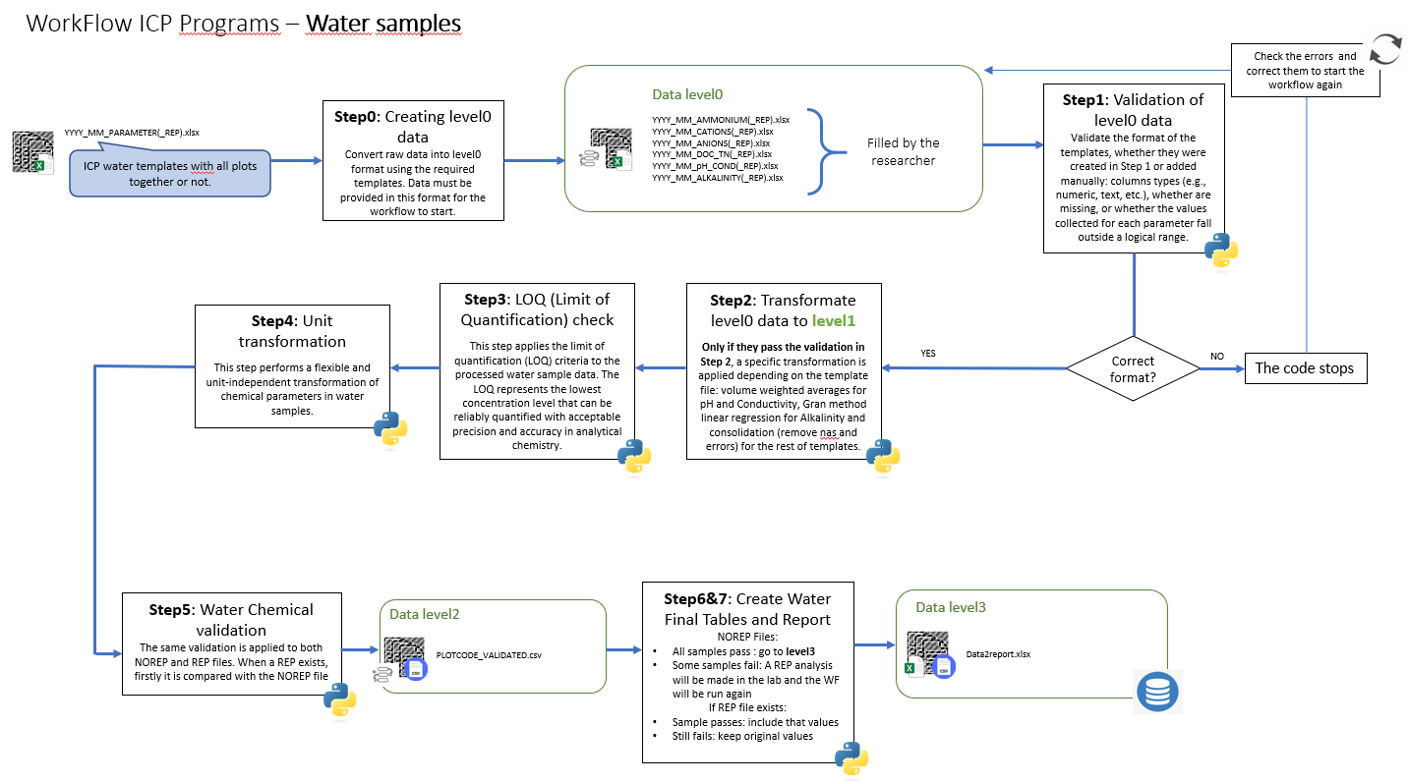

4.2. INCLUDE STEP BY STEP DESCRIPTIONS
STEP 1 (Validation of level0 data):
The purpose of this service is to validate the format of the templates stored in the ZIP file. At this stage, the validation checks include:
- Whether columns contain the expected types of values (numeric, categorical, etc.).
- Whether the recorded values fall within the allowed ranges.
- That there are no negative values where they are not permitted.
- That all columns required for subsequent steps are present.
- That important columns are not empty.
These checks ensure that the templates comply with all formatting and content requirements before proceeding with the workflow. Please refer to the GitLab documentation for instructions on how to fill in the templates and configure the configuration file, where all standards and rules are defined.
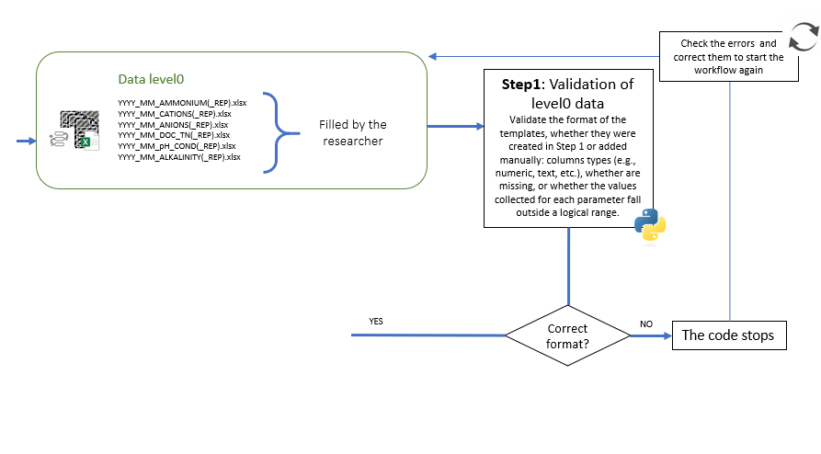
INPUT FILE: 1
- Nickname: allData.zip
- Format: ZIP file containing all filled Excel templates (naming convention: YYYY_MM_PARAMETER(_REP).xlsx)
- Source: Input of the Step1
- Description: The input consists of the filled templates. Each template corresponds to the type of parameters being measured and may repeated samples or not. In cases where REP files exist, they must be accompanied by their corresponding original (NOREP). At this stage, no transformations have been applied to data yet.

INPUT FILE: 2
- Nickname: tables_config.txt
- Format: TXT (JSON array)
- Source: Input of Step1
- Description: This configuration file defines all validation rules applied the templates: expected columns and their data types, required and optional columns, columns that must not contain negative values, allowed value ranges, and regex format constraints. These rules can be adapted to any Excel structure, making this service reusable by any researcher working with different template designs.
OUTPUT FILE: 1
- Nickname: validation_log.txt
- Format: TXT
- Source: Output of Step 1
- Description: A plain-text report listing the validation result for each. Critical errors are marked with ❌, warnings with ⚠️, passing files with ✅. If critical errors are found and is TRUE, the workflow halts and the log identifies which files failed and which rules were violated.
OUTPUT FILE: 2
- Nickname: allData_templates_format_validated.zip
- Format: ZIP file containing all validated Excel templates, naming convention: validated_YYYY_MM_PARAMETER(_REP).xlsx).
- Source: Output of Step 1
- Description: The same templates as the input, with a validated_ prefix added each filename to confirm they have passed the format checks are ready for the next step.
SERVICE: 1
- Nickname: Validation of level0 data
- Description: This service is implemented in Python and systematically reviews all uploaded templates. It checks each template for compliance with the required format and content rules. The validation report is exported alongside the validated files. The goal of this step is also to allow any researcher to review their data in the same standardised way. The only requirement is to fill out the configuration file following the same structure, specifying template names, expected columns, value ranges, which columns cannot have negative values, and which columns must exist. This makes the service fully reusable with different filenames and column names.
- Type: Python code
- Status: Developed and operational
- Availability: Open source
- Dependencies: pandas, numpy, glob, os, datetime, sys, re, zipfile, json, Path, openpyxl, argparse
- Development type: Python open source routine
- Author: J. Torrens
- Reference: none.
- Image: none.

STEP 2 (Transformation of level0 data to level1):
The goal of this service is to perform some important transformations on the results once we have validated that the data has been correctly collected and before the chemical validation is performed. For each type of input (parameter group), a different transformation may be required, so a specific code in the same script is applied accordingly:
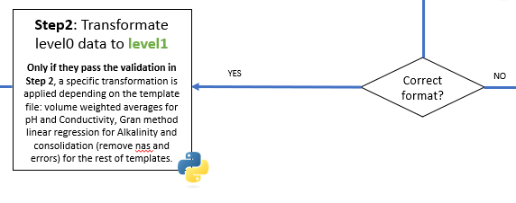
Alkalinity templates (following Gran Method): Alkalinity templates contain multiple titration rows per sample or mixture (depending on lab protocol). The transformation selects the four pH measurements closest to reference pH values (4.0, 4.2, 4.3, 4.5), transforms them into a quantity proportional to [H⁺] while accounting for the volume of HCl and the sample volume, then performs a linear regression (HCl volume vs. this transformed quantity). The x-intercept of the regression gives the equivalence point, from which alkalinity is calculated and expressed in µeq/L. This follows the Gran method (Gran, 1952), widely recommended for low-alkalinity waters.
Weighted pH and Conductivity templates: This code processes the raw pH and conductivity measurements from water collectors (before mix them if needed) to calculate weighted values for each of them. For each sample, multiple measurements may exist, and the workflow calculates weighted averages based on the volume of each subsample. Temperature and dissolved oxygen values are averaged simply, while the total sample volume is summed. Precipitation is estimated using the total volume and the number of valid subsamples (if radius data exists). Conductivity is calculated as a volume-weighted average across all measurements for the sample. For pH, the hydrogen ion concentration (H⁺) is first calculated for each subsample as 10^(-pH) and then averaged using the subsample volumes to obtain a weighted hydron concentration. The weighted pH is then derived as the negative logarithm of the weighted hydron concentration. Finally, the total hydrogen ion concentration per sample is computed in microequivalents per liter. The results are consolidated across months for each site and negative or missing values are handled carefully to ensure accurate weighted calculations, providing a standardized, comparable pH value for each water sample. In case there is only one bucket for a given type of subprogram and there is no need to calculate a weighted average, the code takes this into account, does not compute the average, and keeps the corresponding value.
Ammonium, cations, Anions, DOC, TN templates: For each subprogram, it identifies all relevant Excel files in the input directory and organizes them. For each site, the code reads the monthly Excel files, and the monthly data are concatenated into a single dataset for each site, removing any duplicate entries based on SampleID, SiteCode, SiteName, and EndDate to ensure each sample is represented only once.
INPUT FILE: 1
- Nickname: allData_templates_format_validated.zip
- Format: ZIP file containing validated Excel templates
- Source: Output of the Step 1
- Description: Validated Excel files, each containing a sheet named "data" the measurements. Each file may contain data for multiple. Replicate files (with _REP_ in the filename) are handled automatically.

OUTPUT FILE: 1
- Nickname: water_chemical_data_level1.zip
- Format: ZIP file containing tab-separated CSV files (naming convention: <SiteCode>_WATER_<SUBPROGRAM>.csv)
- Source: Output of this code
- Description: One CSV per SiteCode per subprogram containing the transformed measurements. For ALKALINITY, the computed alkalinity value in µeq/l is included (after the linear regression we get an alkalinity value for that sample). For pH_COND, weighted values are provided for each sample. For the remaining subprograms, data are consolidated and deduplicated.
SERVICE: 1
- Nickname: Transformate level0 data to level1
- Description: This service performs the initial transformation and standardization of raw water sample data within the workflow. It is recommended to follow the previous processing steps before using this service, as they ensure that input data are properly validated and structured. However, the service is flexible and can be used independently by any researcher working with similar water sample datasets.
Users may not need to execute the entire workflow to benefit from this service. For example, it can be used specifically to calculate alkalinity using the Gran method or to compute weighted pH values based on subsample volumes. Therefore, the different components included up to this stage can be applied separately depending on the user’s needs. They would just need to include the alkalinity tables in the template format, validate the format, and that’s it. So this service is conditionally reusable: The individual transformation routines (Gran alkalinity, weighted pH/conductivity, parameter concatenation) can each be used independently by any researcher working with comparable water chemistry data structured in the same template format.
The service integrates several processing routines, including alkalinity estimation through linear regression (Gran method), weighted calculations for pH and conductivity, and basic transformations for chemical parameters such as ammonium, anions, cations, DOC, and TN. These processes ensure consistent, comparable, and quality-controlled outputs across different water samples, regardless of program or subprogram.
From a technical perspective, Pandas is used for data manipulation and structuring, NumPy for numerical operations, and scikit-learn for linear regression calculations.
- Type: Python code
- Status: Developed and operational
- Availability: Open source
- Dependencies: Pandas, numpy, os, Path, openpyxl.
- Development type: Python open source routine
- Author: J. Torrens
- Reference: none.
- Image: none.

STEP 3 LOQ (Limit of Quantification) check:
This step applies the limit of quantification (LOQ) criteria to the processed water sample data. The LOQ represents the lowest concentration level that can be reliably quantified with acceptable precision and accuracy in analytical chemistry. For each parameter, predefined LOQ thresholds are used. When a measured value falls below its corresponding LOQ, it is replaced by half of the LOQ value (LOQ/2). This approach is commonly applied in environmental studies to avoid bias introduced by non-detects while maintaining statistical consistency. The LOQ values are defined as input parameters and can be modified by the user.
Additionally, all modifications are recorded in a log file, ensuring full traceability of the data processing steps.

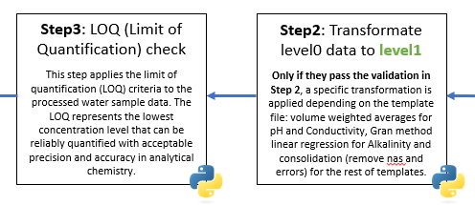
INPUT FILE: 1
- Nickname: water_chemical_data_level1.zip
- Format: ZIP file containing tab-separated CSV files
- Source: Output of the Step 2
- Description: Tab-separated CSV files with water chemistry measurements, one per SiteCode per subprogram. Compatible with any CSV set following the {ANALYTE}(unit) column naming convention. Column names are matched case-insensitively.
OUTPUT FILE: 1
- Nickname water_chemical_data_level1_loq.zip
- Format: ZIP file containing tab-separated CSV files
- Source: Output of this code
- Description: Same CSV files as the input, with all values below their respective LOQ replaced by LOQ/2.
OUTPUT FILE: 2
- Nickname loq_substitutions.log
- Format: TXT (tab-separated)
- Source: Output of this code
- Description: Traceability log recording every substitution made. Columns: FILE, ROW, COLUMN, ORIGINAL_VALUE, LOQ, REPLACED_BY. This file allows auditing of all LOQ corrections applied to the data.

SERVICE: 1
- Nickname: Apply LOQ threshold
- Description: This service performs the automatic detection and correction of values below the limit of quantification (LOQ) across multiple water quality parameters. It is recommended to apply this step after the initial data transformation (Step 4), as it relies on standardized and validated input data.
However, the service can also be used independently by researchers working with similar datasets who need to handle censored data (values below detection limits). The method implemented replaces values below LOQ with half the detection limit (LOQ/2), a widely accepted approach in environmental and water quality studies.
The service processes multiple parameters simultaneously, including conductivity, nutrients, major ions, trace metals, and organic matter indicators (DOC and TN), ensuring consistency across all variables. In addition, it generates a detailed log file to track all applied corrections, supporting reproducibility and auditability of the workflow.
From a technical perspective, Pandas is used for data manipulation and filtering, while standard Python libraries such as os handle file management. The library openpyxl is included for compatibility with Excel-based workflows.
The service is conditionally reusable by any researcher working with quantitative analytical data who needs to handle censored values. The LOQ thresholds are declared as input parameters and can be freely changed. The only requirement is that the input CSV files share the same column naming convention for the parameters listed in the configuration (mg/l), so the parameters to be checked must belong to this group.
- Type: Python code
- Status: Developed and operational
- Availability: Open source
- Dependencies: Pandas, openpyxl, os, zipfile, openpyxl.
- Development type: Python open source routine
- Author: J. Torrens
- Reference: none.
- Image: none.

STEP 4 (Unit transformation):
This step performs a flexible and unit-independent transformation of chemical parameters in water samples. Unlike previous implementations, the transformation no longer assumes a fixed input unit (mg/L), but automatically detects and standardizes values provided in mg/L, µg/L, or µeq/L.
All recognized analytes are internally converted to mg/L and then used to generate consistent outputs in:
- mg/L
- µg/L
- µeq/L
This approach ensures robustness when integrating heterogeneous datasets from different laboratories or monitoring programs, where units may vary.
Additionally, the workflow derives chemically meaningful variables (e.g., NO₃–N, SO₄–S, PO₄–P) based on stoichiometric relationships, atomic weights, and valence. This is essential in water chemistry for comparing ionic balances and nutrient forms.
SUPPORTED PARAMETERS FOR UNIT TRANSFORMATION
The code allows transformation (from any supported unit) of the following parameters:
Nutrients and molecules:
- NH₄⁺ / NH₄–N
- NO₃⁻ / NO₃–N
- SO₄²⁻ / SO₄–S
- PO₄³⁻ / PO₄–P
- DOC (Dissolved Organic Carbon)
- TN (Total Nitrogen)
Major ions:
- Cl⁻
- Na⁺
- K⁺
Major cations
- Ca²⁺
- Mg²⁺
- Na⁺
- K⁺
Trace elements and metals
- As
- Cd
- Cr
- Cu
- Co
- Ni
- Pb
- Zn
- Al
- Fe
- Mn
Additional elements
- P
- S
SPECIAL STOICHIOMETRIC CONVERSIONS
The code also performs bidirectional transformations between:
- NH₄ ↔ NH₄N
- NO₃ ↔ NO₃N
- SO₄ ↔ SO₄S
- PO₄ ↔ PO₄P
These conversions are based on molecular weights and elemental fractions, ensuring chemically consistent results.

SUPPORTED INPUT UNITS
The system automatically detects and normalizes:
- mg/L
- µg/L (also accepts ug/L, μg/L)
- µeq/L (also accepts ueq/L, μeq/L)

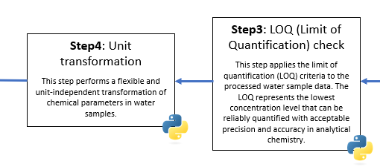
INPUT FILE: 1
- Nickname: water_chemical_data_level1_loq.zip
- Format: ZIP file containing tab-separated CSV files
- Source: Output of the Step 3
- Description: LOQ-corrected CSV files. Compatible with any CSV set following the {ANALYTE}(unit) column naming convention. Supported input units: mg/l, µg/l, ug/l, µeq/l, ueq/l.
OUTPUT FILE: 1
- Nickname water_chemical_data_level1_units.zip
- Format: ZIP file containing tab-separated CSV files
- Source: Output of this code
- Description: Same CSV files expanded with three unit columns per analyte. For example, a file containing NH4N(mg/l) will also contain NH4N(µg/l) and NH4N(µeq/l) after this step. Both the original and derived unit columns are preserved.
SERVICE: 1
- Nickname: Unit conversion and chemical transformation
- Description: This service performs automatic unit detection and conversion for water chemistry datasets, allowing users to input data in different unit systems without prior standardization.
It is recommended to apply this step after LOQ correction, although it can be used independently on raw datasets. The service is particularly useful when integrating multi-source data or historical datasets with inconsistent units.
Key functionalities include:
  - Automatic detection and normalization of input units
  - Conversion between mg/L, µg/L, and µeq/L
  - Stoichiometric transformations between molecular and elemental forms
  - Generation of consistent multi-unit outputs for each analyte
  - Support for a wide range of nutrients, ions, and trace elements
This methodology follows standard practices in aquatic chemistry and ensures comparability across datasets, especially when performing ionic balance or nutrient analysis.
From a technical perspective, Pandas is used for data manipulation, re for parsing column names and units, and openpyxl for compatibility with Excel workflows. Additional libraries such as zipfile are used to package results.
The service is conditionally reusable by any researcher working with water chemistry data who needs to harmonise units across datasets or convert between mg/L, µg/L, and µeq/L. The service automatically detects input units — no manual preprocessing required. Input files must use column names following the conventions used in the ICP templates (e.g., CL(mg/l), NH4N(mg/l)).
- Type: Python code
- Status: Developed and operational
- Availability: Open source
- Dependencies: Pandas, zipfile, os, re, openpyxl.
- Development type: Python open source routine
- Author: J. Torrens
- Reference: none.
- Image: none.

STEP 5 (Water Chemical Validation):
This step performs the final chemical validation of water samples, integrating all previously processed parameters into a unified dataset and applying a series of physicochemical consistency checks. The process begins by merging all water-related datasets (ammonium, anions, cations, DOC/TN, weighted pH and conductivity, and alkalinity) into a single file per SiteCode. Each row represents a sampling event (date), and all available years are combined into the same dataset to allow validation across time.
Once merged, the workflow applies multiple validation criteria based on established principles of aquatic chemistry, including ionic balance, conductivity consistency, and stoichiometric relationships (e.g., Aquatic Chemistry Stumm and Morgan).
Additionally, the workflow integrates sampling typology information (if available), allowing specific corrections and calculations depending on the type of sample (e.g., surface water).
The checks include:
· Ionic balance (sC - sA) with and without organic anion correction.
· Na/Cl ratio (indicator of sea-salt influence or contamination).
· Comparison between measured and theoretically calculated conductivity.
· Organic nitrogen consistency (TN vs NO3-N + NH4-N).

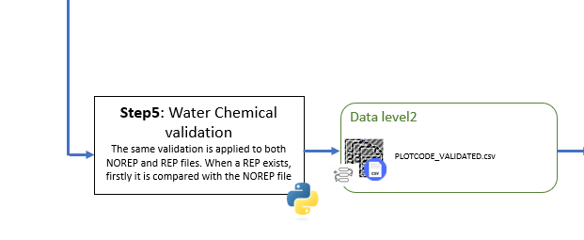
It is important to note that for each SITECODE, the merge can result in two independent files: the original analysis and a repeated analysis, if a repetition was required. If there are duplicates, they are merged in the same way into the file where we store all samples and are validated as an additional row. If only some sample parameters are duplicated, any missing data required for validation is taken from the original. This way, we have a complete view of which samples have passed validation, allowing us to generate the report and select the samples of interest.
INPUT FILE: 1
- Nickname: water_chemical_data_level1_units.zip
- Format: ZIP file containing tab-separated CSV files
- Source: Output of the step 4
- Description: Input files containing fully processed water sample data, including:
  - Unit-standardized chemical concentrations
  - LOQ-corrected values
  - Derived variables (e.g., NO₃–N, SO₄–S, alkalinity)
  - Weighted pH and conductivity

INPUT FILE: 2
- Nickname: samplesInfo.xlsx
- Format: Excel file (.xlsx)
- Source: External input (provided by the researcher)
- Description: Mapping file that assigns a SamplingTypology to each SampleID (e.g. THR CON, BOF BL, SW CON). Required columns: SampleID, SamplingTypology. If this file is not provided, all typology-dependent checks are skipped (Org- estimation, BOF/WET ion balance filter, Na/Cl filter).

OUTPUT FILE: 1
- Nickname: water_chemical_data_level2_alldata.zip
- Format: ZIP file containing tab-separated CSV files
- Source: Output of this code
- Description: Merged pre-validation CSV per SiteCode. Contains all subprogram columns joined in a single wide table, before any quality indicators are computed.

OUTPUT FILE: 2
- Nickname: water_chemical_data_level2_validated.zip
- Format: ZIP file containing tab-separated CSV files
- Source: Output of this code
- Description: Validated CSV per SiteCode with all quality indicator columns appended (ionic balance, conductivity difference, Na/Cl ratio, ionic strength, ionic activity factor, etc.) and the FINAL_VALIDATION flag (SI/NO) per sample.

SERVICE: 1
- Nickname: Chemical quality validation
- Description: The first step in this process is to merge the different water-related files (ammonium, anions, cations, DOC/TN, pH, and alkalinity) into a single dataset, since all parameters are needed for the calculations. This merging is done by SITECODE, SAMPLEID and DATE, meaning that for each plot, all related parameters are combined, and validation is then performed for each date with available values. Then, the code fills replicate samples with base sample metadata, joins the sampling typology, and applies 14 sequential calculation modules to derive all chemical quality indicators. The FINAL_VALIDATION flag is set to NO when a sample fails the ion balance (BOF/WET samples), conductivity check, organic nitrogen check, or Na/Cl ratio (BOF/WET/THR/STF samples). All quality thresholds are configurable parameters with ICP default values. From a technical perspective, Pandas and NumPy are used for vectorized calculations and data processing.
- Type: Python code
- Status: Developed and operational
- Availability: Open source
- Dependencies: os, re, sys, dataclass, typing, numpy, pandas, opnpyxl.
- Development type: Python open source routine
- Author: J. Torrens
- Reference: none.
- Image: none.

STEP 6 (Validation report generation):
The purpose of this service is to generate a comprehensive validation report from the validated data. It consolidates all SiteCode CSV files, fills typology information for replicate samples, and produces three outputs: a multi-page PDF report with charts and a colour-coded validation table, an Excel file listing only the samples that failed validation (samples to be repeated), and an Excel file with all samples. The report compares two scenarios — the original non-replicate samples and a scenario where validation results are replaced by those of their replicates — to assess whether repetition improves data quality. Then produces three outputs:
- allFinalData.xlsx: Consolidated validated dataset in the format required for the BIOMA internal database.
- Samples2repeat.xlsx: List of samples that failed both NOREP and REP validation and must be re-analysed in the laboratory.
- validation_report.pdf: A human-readable report summarising validation outcomes per site, parameter group, and month.
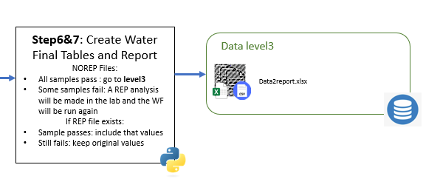

INPUT FILE: 1
- Nickname: water_chemical_data_level2_validated.zip
- Format: ZIP file containing tab-separated CSV files
- Source: Output of the step 5
- Description: Validated CSV files per SiteCode, each containing the FINAL_VALIDATION flag and all quality indicator columns.

INPUT FILE: 2
- Nickname: samplesInfo.xlsx
- Format: Excel file (.xlsx)
- Source: External input (provided by the researcher).
- Description: SampleID → SamplingTypology mapping. Used to fill typology for replicate samples and to define the sample sort order in the report tables.

OUTPUT FILE: 1
- Nickname: All_Validated_Data.xlsx
- Format: xlsx
- Source: Output of this code
- Description: Contains all samples regardless of validation outcome, with same column layout and red highlighting for missing values. Used as input for Step 7.

OUTPUT FILE: 2
- Nickname: Samples2Repeat.xlsx
- Format: Excel file (.xlsx)
- Source: Output of this code
- Description: Contains only the samples that failed validation (FINAL_VALIDATION= NO), sorted by year, month and SampleID. Empty cells are highlighted in red. This file is used to identify which samples need to be repeated.

OUTPUT FILE: 3
- Nickname: validation_report.pdf
- Format: PDF
- Source: Output of this code
- Description: Multi-page PDF report. Page 1 contains key indicators and a 3×2 chart grid: (1) failed validations by month, (2) failure type breakdown, (3) typology stacked bar chart, (4) heatmap of failure rate by typology × month, (5) failure rate by SiteCode, (6) REP improvement rate by typology. Subsequent pages show the failure rate ranking by sample (colour gradient) and a colour-coded per-sample validation table.

SERVICE: 1
- Nickname: Validation report
- Description: This service consolidates all validated CSV files, fills replicate typology from samplesInfo.xlsx, deduplicates by keeping the row with the fewest missing values per sample per month, and generates all report outputs. The REP vs NOREP comparison keeps sample counts identical in both scenarios, making the comparison methodologically sound. Charts are generated with matplotlib and embedded in the PDF via fpdf2.
- Type: Python code
- Status: Developed and operational
- Availability: Open source
- Dependencies: pandas, numpy, fpdf, matplotlib, openpyxl, re, os.
- Development type: Python open source routine
- Author: J. Torrens
- Reference: none.
- Image: none.

STEP 7 (Select Data for Final Tables):
- This step reads allFinalData.xlsx from Step 6, merges it with the sampling typology metadata, and applies the full NOREP/REP selection logic to produce the final Level 3 dataset ready for database ingestion and reporting.
- The selection algorithm per (base sample ID, year, month) group:
  - If the original NOREP sample passed validation → keep NOREP.
  - If NOREP failed but REP passed → keep REP.
  - If both NOREP and REP failed and both exist → keep NOREP.
  - If only NOREP exists and it failed → discard.
- After selecting the valid sample, samples collected at the same site during the same month should be aggregated using a weighted average, resulting in a single reported value per month, site, and parameter within each subprogramme.
INPUT FILE: 1
- Nickname: All_Validated_Data.xlsx
- Format: Excel file (.xlsx)
- Source: Output of step 6
- Description: All validated water chemistry samples with the VAL column (SI/NO). Both original and replicate samples are included. The selection logic in this step determines which rows to keep in the final output.

INPUT FILE: 2
- Nickname: samplesInfo.xlsx
- Format: Excel file (.xlsx)
- Source: External input (provided by the researcher)
- Description: SampleID → ICP_Program / SamplingTypology / Instrument / ID_PostgreSQL mapping. These metadata columns are merged into the output to provide the full context required for ICP programme reporting and database ingestion.

OUTPUT FILE: 1
- Nickname: data2report.xlsx
- Format: Excel file (.xlsx)
- Source: Output of this code
- Description: One row per sample per month containing the final chemistry columns, ready for submission to the ICP programme and ingestion into the PostgreSQL database. Columns always present in the output regardless of data availability: SampleID, SiteCode, SiteName, year, month, CL(mg/l), SO4S(mg/l), NO3N(mg/l), PO4P(mg/l), CA(mg/l), MG(mg/l), NA(mg/l), K(mg/l), AL(mg/l), FE(mg/l), MN(mg/l), AS(mg/l), CD(mg/l), CR(mg/l), CU(mg/l), CO(mg/l), MO(mg/l), NI(mg/l), PB(mg/l), ZN(mg/l), P(mg/l), S(mg/l), NH4N(mg/l), TN(mg/l), DOC(mg/l), H(µeq/l), WeightedConductivity(µS/cm), Volume(ml), Precip(l/m2), WeightedpH, AlkalinityICPForests(µeq/l).

SERVICE: 1
- Nickname: Validation report
- Description: This service merges All_Validated_Data.xlsx with samplesInfo.xlsx to attach programme and instrument metadata, identifies replicate samples by the REP suffix in the SampleID, and applies the four-rule selection logic to produce one clean row per sample per month. Wether ,after selecting the valid sample, samples collected at the same site during the same month should be aggregated using a weighted average, resulting in a single reported value per month, site, and parameter within each subprogramme. The output is formatted for direct use in ICP programme reporting and PostgreSQL ingestion.
- Type: Python code
- Status: Developed and operational
- Availability: Open source
- Dependencies: pandas, openpyxl, os.
- Development type: Python open source routine
- Author: J. Torrens
- Reference: none.
- Image: none.

